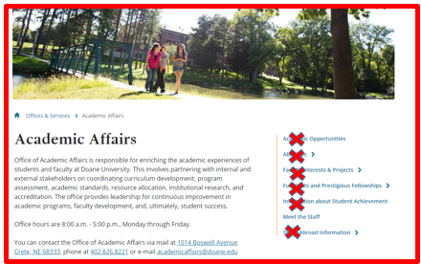
Academic Affairs
Academic Affairs is organized around three colleges and one school, and provides services and support to all Doane University faculty and students.
Services within Academic Affairs are provided by staff in the Office of Academic Affairs, Registrar, the Academic Success Center and the Writing Center.
Office of Academic Affairs
Office hours are 8:00 a.m. – 5:00 p.m. CST, Monday through Friday.
Phone 402 .826.8221, email academicaffairs@doane.edu, 1014 Boswell Avenue, Crete, NE 68333.

(links)
Academic Support Center >
College of Arts & Science >
College of Business >
College of Education >
School of Innovative Learning (in transition) >
Meet the Staff >
Registrar >
Writing Center >

