To create your Nelnet student account for the first time, click this link and follow the below instructions:

- Log in with your Doane credentials.
- Enter the requested information.

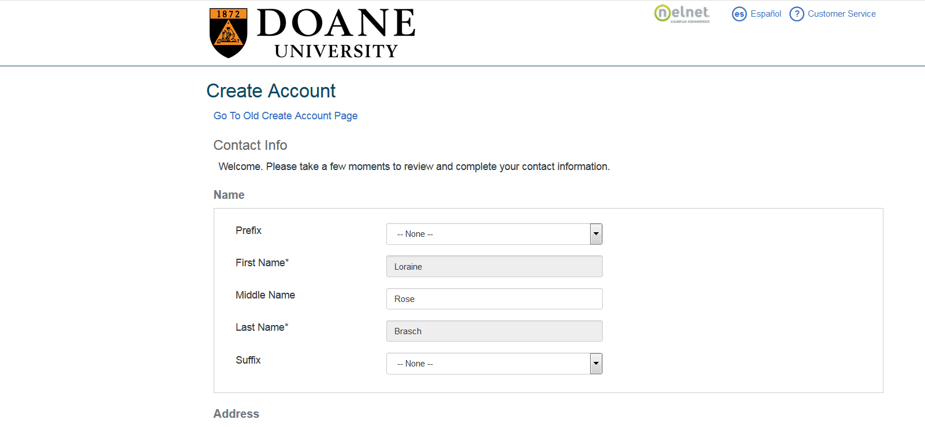
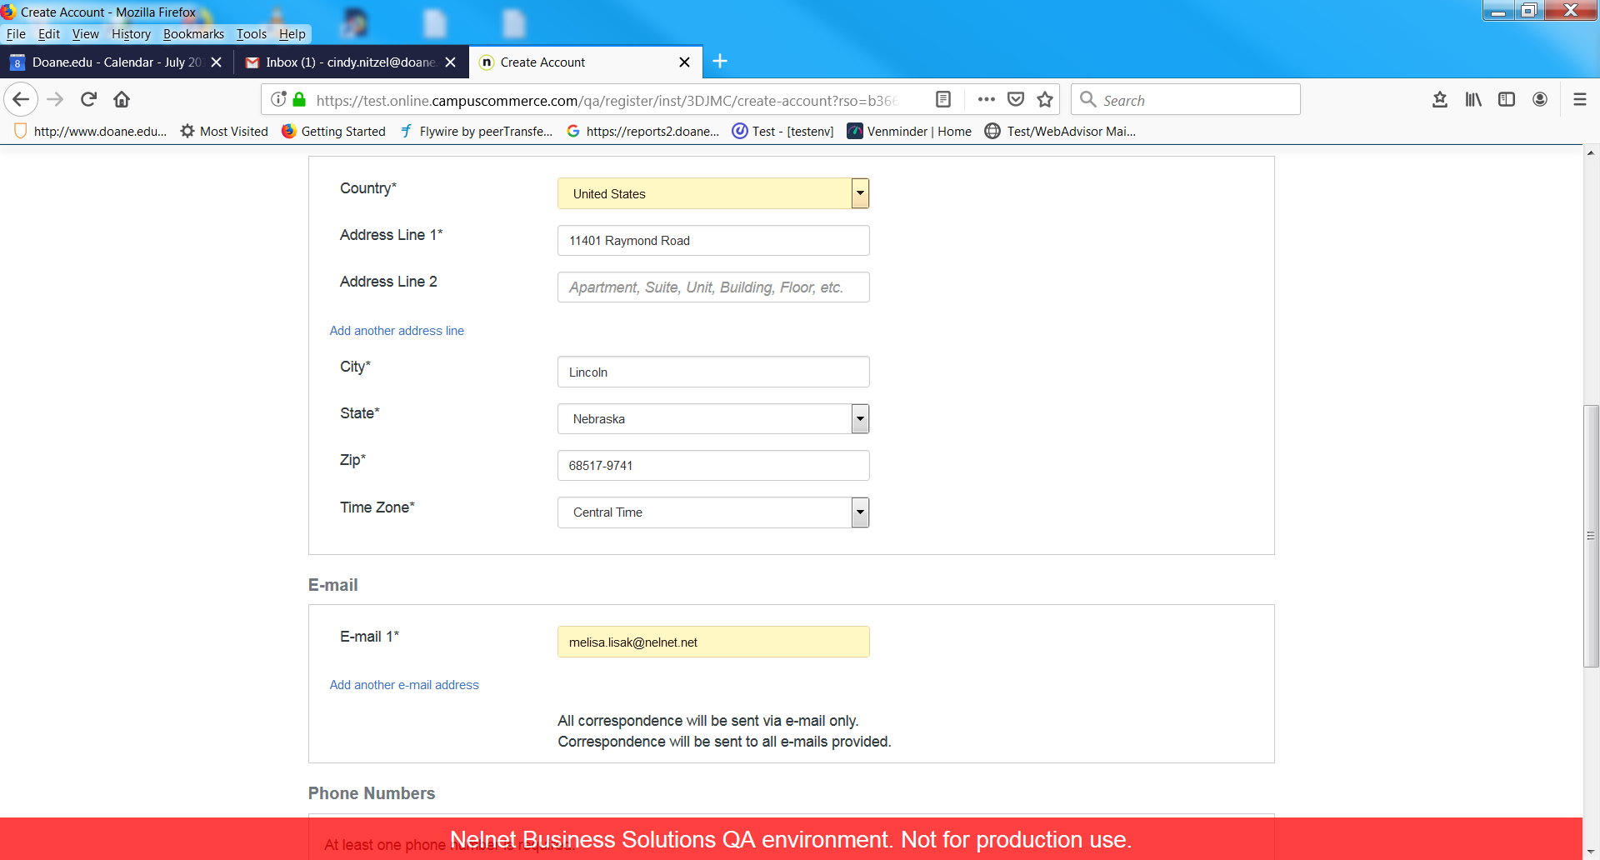

Once students have created their account, they will be able to:

* View their student account balance

* Make one time payments

* Sign up for monthly installment plans/deferred employee reimbursement plans

* Enroll in “text” alerts

* Assign authorized payers of their student account

* Set up Direct Deposit for Financial Aid Refunds (if applicable)

