To set up electronic deposit for your student account, click this link and follow the below instructions:

- Log in with your Doane credentials.

- If you, have not already set up your account with Nelnet, after you log in, you will need to create your Nelnet account by entering the requested info. Then you will be able to set up electronic deposit by following the steps below.

- If you already have an account set up with Nelnet, you will be directed to your Nelnet account homepage.

- Select the “Manage Refunds” button.

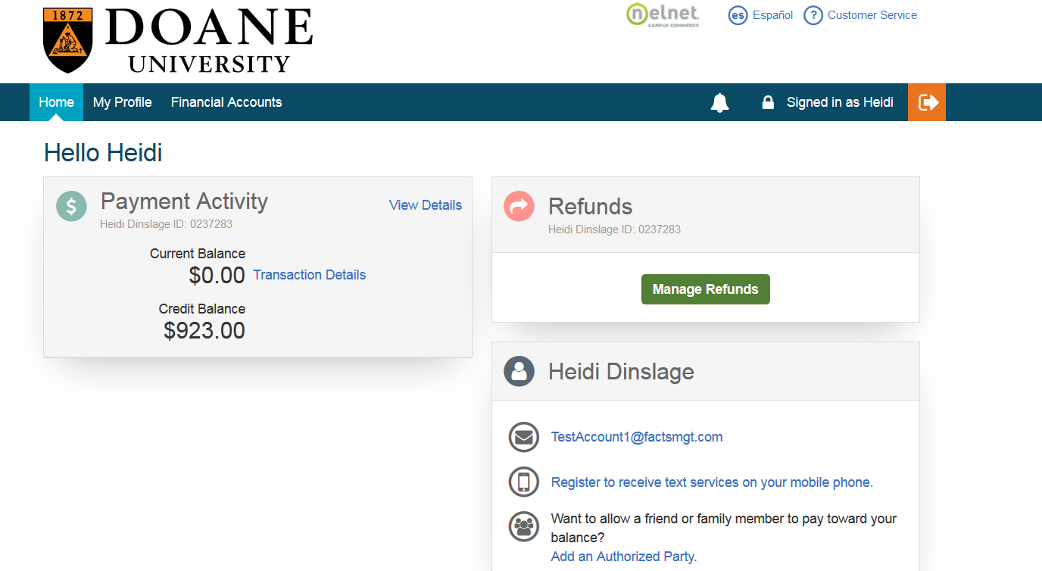

- Verify your information is correct

- Select Bank Bank Account and enter your bank information

NOTE: If you do not receive the authorization code, please check your “SPAM” folder.

