Reviewing, Coding, and Attaching Receipts
Doane’s policy requires that all transactions be reviewed, have General Ledger Accounts associated with them, descriptions, images, and approval by supervisors. Failing to do so may result in the card holder having taxable income according to IRS rules. Please review each transaction and ensure all transactions have complete information.

- From the Cardholder home screen, select Account Activity/Transaction Summary. Choose the date range that needs to be reviewed and click “Search”
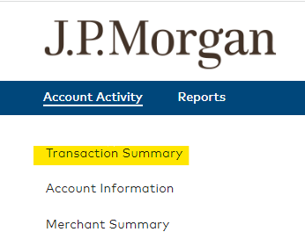
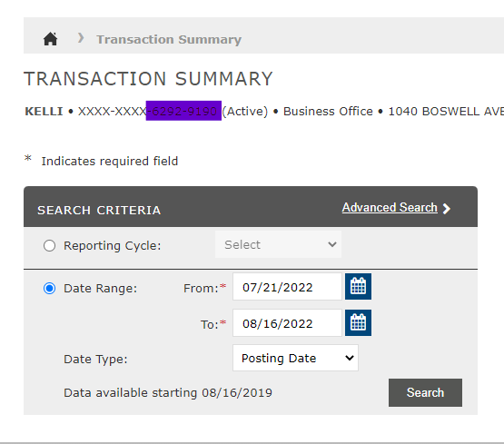

- This will bring up the transactions for the selected time period. To review a specific transaction click on the Right Arrow icon.
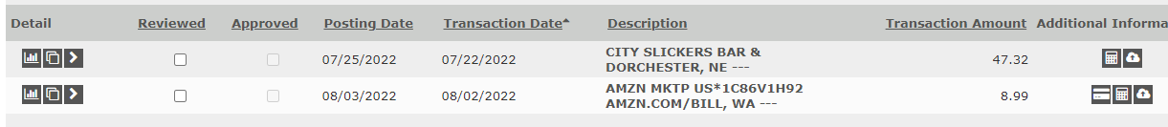

- Enter a brief description of the transaction. The University and the IRS require detailed descriptions to demonstrate the business purpose of the transaction. Failing to put a detailed transaction may result in rejection by the IRS and taxes charged to the employee.

Insufficient Description: Dinner at conference with coworkers
Better Description: Dinner while at conference on student enrollment best practices. Tom, Dick, and Sally in attendance.

Insufficient Description: Equipment.
Better Description: 25 Mouth guards for the Football team.

- The transaction can now be coded for the appropriate General Ledger (GL) account using the drop down boxes. If unsure of the correct code please contact the Business Office for guidance. If applicable, enter the grant account or the capital project number in the “Grant Name/Job#” field.
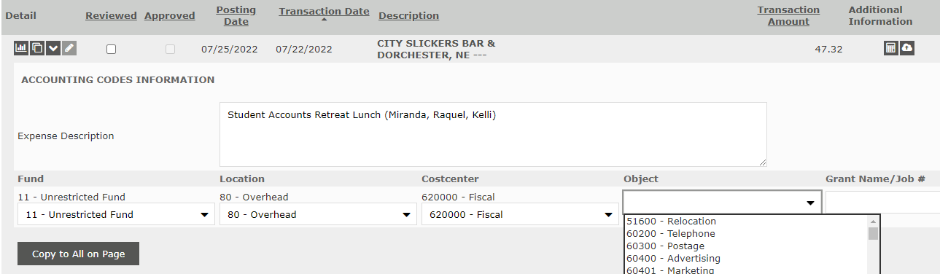

5. If a single transaction should be split between multiple GL accounts, click the Double Box icon.
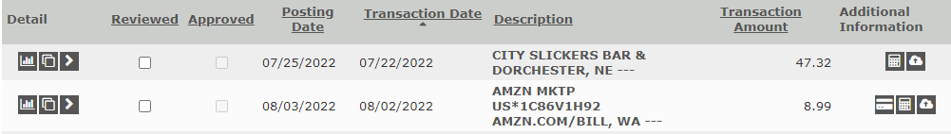

6. Select whether to split the transaction by a specific amount or by a percent. Enter the number of accounts to share the transaction cost. Click the Plus icon.
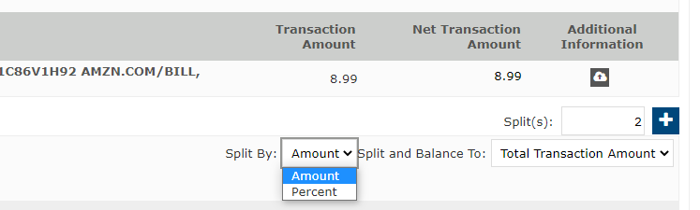

7. Adjust the percentages or amounts as needed. Enter the description for each split.
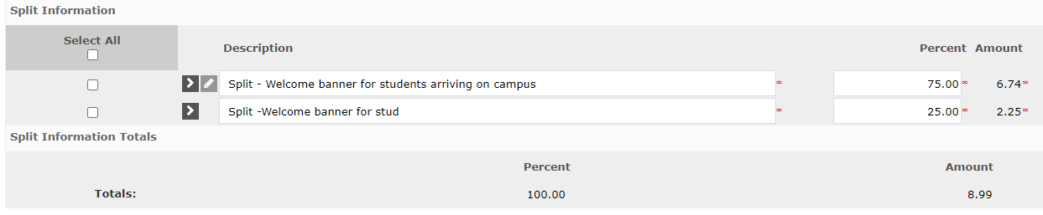

8. Select the Right Arrow icon by the first split, enter the GL codes, and click the Save icon. Repeat for each additional split.
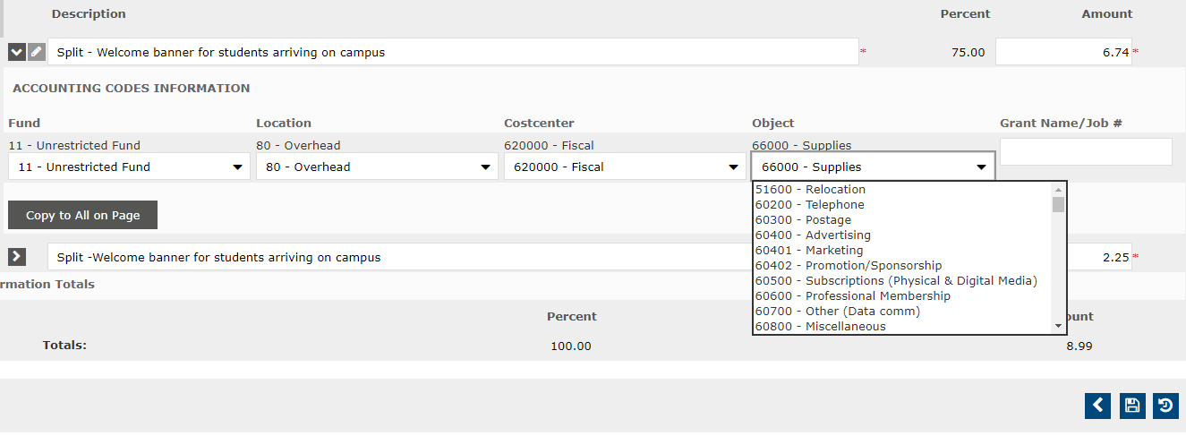

9. Click the Cloud with Up Arrow icon to upload the receipt. Click “Browse,” select the receipt file and click “Open”. Then Click “Add”
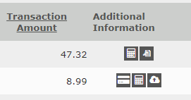
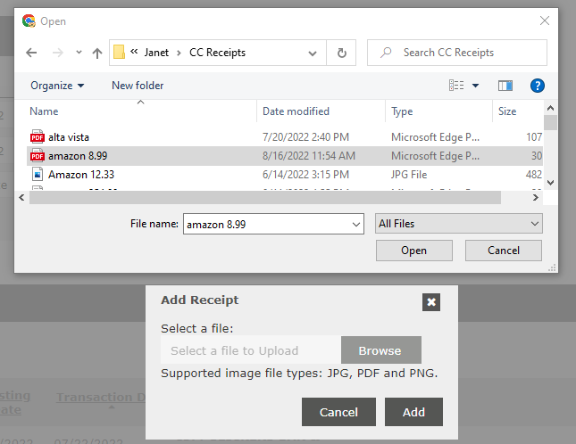

10. A receipt must be provided for all purchases made with Doane credit cards.
- If the receipt is from a restaurant include the itemized receipt and the charge receipt with the tip included (both receipts).
- For international fees upload the receipt for the international purchase that incurred the fee.
- On the rare occasions when receipts are not available at the point of purchase (i.e. parking meters) include that information in the description.
- If the receipt is misplaced, contact the business to get a copy of the receipt. If the business cannot provide, upload the Lost Receipt Form with supervisor signature in place of the receipt.

