How to Log In
SmartData is the system used by JP Morgan to manage your card activity. This is how you will review transactions, attach receipts, and input General Ledger (GL) numbers. After your account is set up, you will receive emails from the Business Office and JP Morgan. These emails will contain your user ID and a temporary password. You will need to change your password after the first log in. You will also need to set up challenge questions and answers. Every three to six months you will be prompted to update your password. Ensure that you protect your user ID, password, and challenge questions. If you forget your password or challenge questions, Janet Whitehurst in the Business Office can reset these for you.
To log in visit: https://smartdata.jpmorgan.com
Enter in your user ID and password:
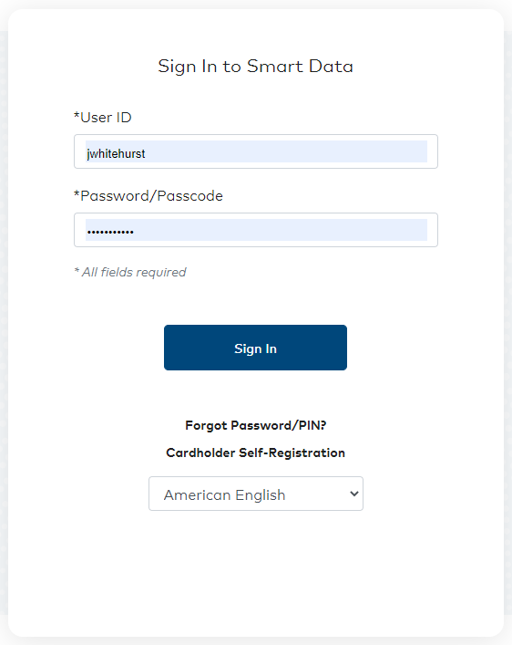
You will also need to answer some challenge questions.

